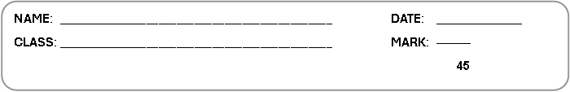

1 Match the countries to the nationalities.

Spoji nazive država s nacionalnostima.
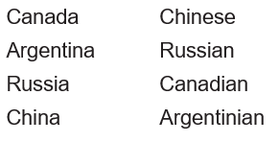
2 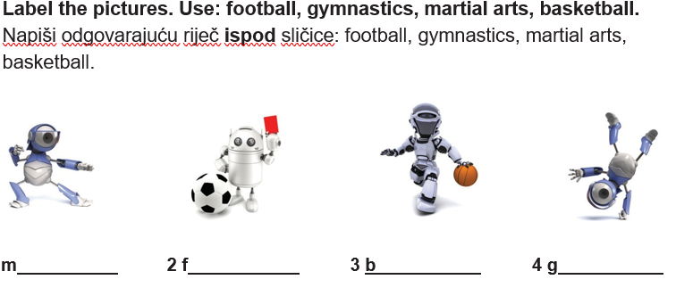

3 Look at the table. Complete the sentences with CAN or CAN’T.

Pogledaj tablicu i dovrši rečenice riječima CAN ili CAN’T.

 | Mark | Chloe
do martial arts | × | √
drive a car | √ | ×
ride a bike | √ | √
ride a skateboard | × | ×
play football | × | √

1 Mark CAN’T do martial arts.

2 Chloe drive a car.

3 Mark & Chloe ride a bike.

4 Mark &Chloe ride a skateboard.

5 Chloe play football.

4 Underline the correct item.

Podcrtaj točnu riječ.

1 This is Laura and this is she / her sister, Julie.

Ovo je Laura, a ovo je ona / njezina sestra Julie.

2 He / His is Ben.

On / Njegov je Ben.

He / His new bag is black.

On / Njegova nova torba je crna.

3 Hi! I / My name is Sarah.

Pozdrav! Ja / Moje ime je Sarah.

4 Ed is I / my friend from London.

Ed je ja / moj prijatelj iz Londona.

5 Complete the sentences with am, is, are.

Dovrši rečenice riječima: am, is, are.

1 I am happy. Ja sam sretan.
2 I John.

3 They British.

4 We from Australia.

5 She very tall.

6 He my friend.

6 Match sentences 1-4 to sentences a-d.

Spoji rečenice od 1-4 s rečenicama od a-d.

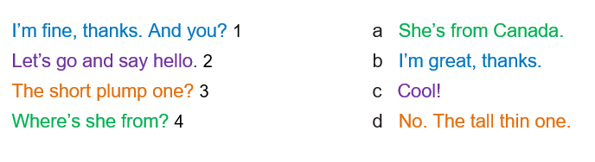
7 Look at the picture and complete the text with: thin (x2), plump (x2), tall (x2), short (x2).
Pogledaj sliku i dovrši tekst riječima: thin (x2), plump (x2), tall (x2), short (x2).

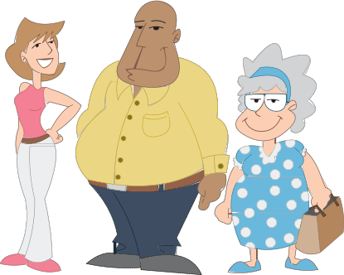
Hi! My name is Jorge and I’m 11 years old.
I’m s and t .

My mum Sandy is 42 years old.

She is t and t .
My dad Roberto is 44 years old.
He is t and p .
My grandma Maria is 80 years old.
She is s and p .

