NAME: ______________________________________________ DATE: _______________
CLASS: ______________________________________________ MARK: ––––––

(Time: 35 minutes)

1.Fill in the gaps with: get up, have breakfast, go to bed,
play video games, do homework, take a shower.
Dopuni praznine riječima: get up, have breakfast, go to bed,
play video games, do homework, take a shower.

1 I get up at 7 o' clock.
2 I _____________ every morning.
3 I ______________ after school.
4 I __________ in the afternoon.
Igram videoigrice poslijepodne.
5 I _____________ in the evening.
Tuširam se navečer.
6 I _____________ at half past 9.
Idem na spavanje u 9:30.
2. What's the time? Draw.
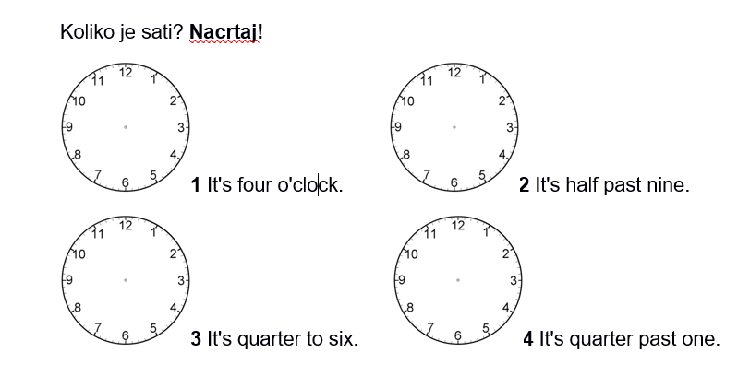

3. Complete the sentences with the correct time.
Dovrši rečenice koristeći točno vrijeme.

A typical Monday
On Mondays I get up at _a quarter past seven_(7.15) and have breakfast with my family.
I go to school at ____________________________________ (7.45).
School starts at _____________________________________(8.15).
I finish school at ___________________________(15.30) and go back home.
In the afternoon I do my homework.
In the evening, I watch videos online or I play video games.
I go to bed at ________________________________________(21.30).
What about you?

4. Use the verbs finish, play, dance and drink to finish the sentences.
Dopuni rečenice glagolima: finishes, play, dances, drink.
1 Michael plays video games at weekends.
2 I ______________ tea in the morning.
3 My sister _______________ at dancing classes.
4 Tom _____________ work at 5 pm.

5. Fill in the gaps with: go, listen, watch, hang out, play.
Dopuni praznine glagolima: go, listen, watch, hang out, play.

Hi everyone!
Weekends are fun.
I chat online with my friends on Saturday mornings.
In the afternoon, I hang out with my cousins.
We ________ to the amusement park or to the mall.
Sometimes, we ________ a film in the mall.
In the evening I __________ board games with my little sister.
I ________ to music before I go to bed.

6. Fill in the gaps with: AT, IN, ON.
Dopuni rečenice riječima: AT, IN, ON.
Sophie gets up at7 o'clock _____ Mondays.
She writes music for video games _____ the morning.
_____ the afternoon she works on her computer.
She does housework _____Saturdays.
____ the evening she chats or goes out with her friends.
She goes jogging in the park _____ noon.

7. Circle the correct verb.
Zaokruži točan glagol.
1 I often watch / go a film in the evening.
2 My brother makes / plays board games at weekends.
3 Kids often go / play to amusement parks.
4 My parents shop / go to the mall on Saturdays.

8.959 Fill in the correct preposition of movement/direction:
out of, over, across, along.

