Name and surname: ________________________ Grade: ___________ ___/31
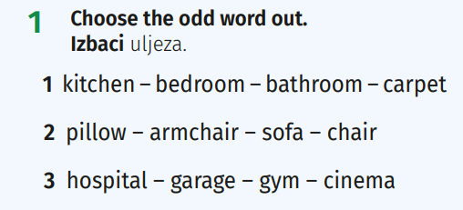

2 Match the rooms and actions.

Spoji prostorije i radnje.

1 You sleep there. A living room
2 You eat there. B bathroom
3 You brush your teeth there. C bedroom
4 You watch TV there. D kitchen
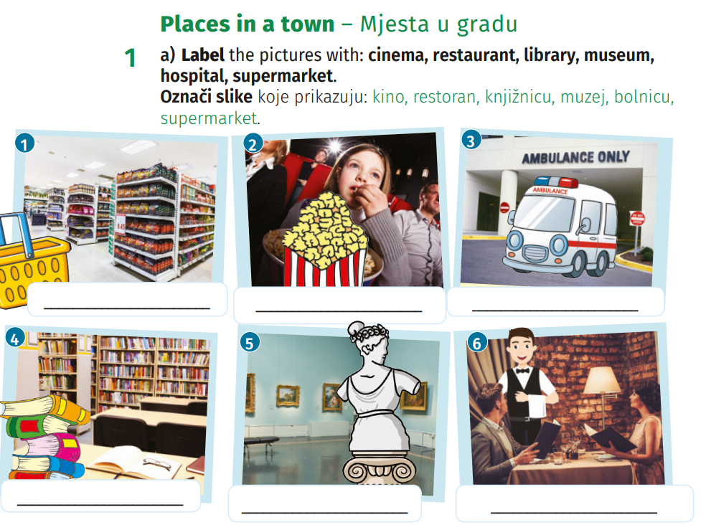

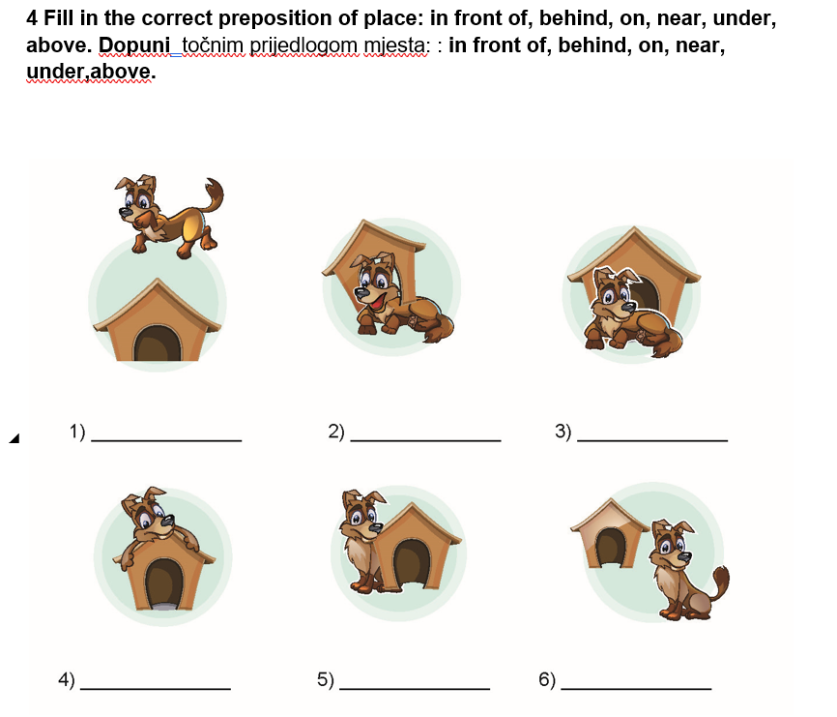

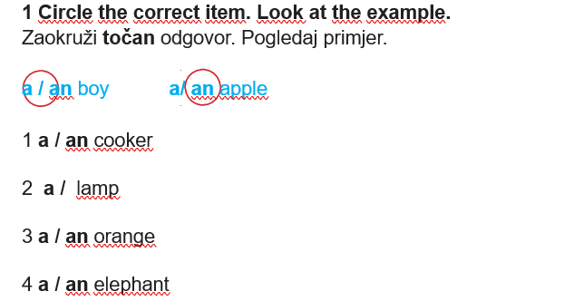

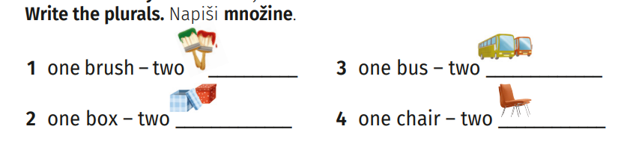

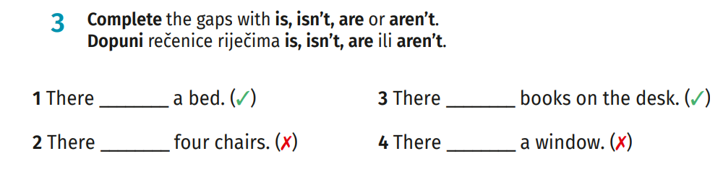

LISTENING COMPREHENSION /15
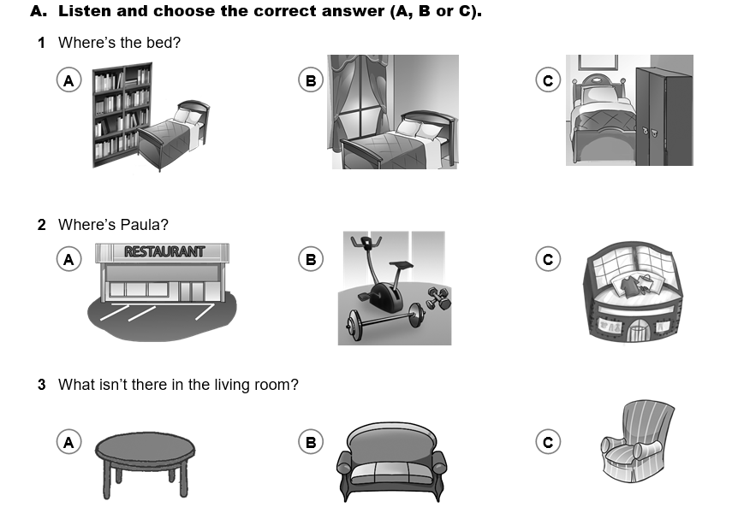

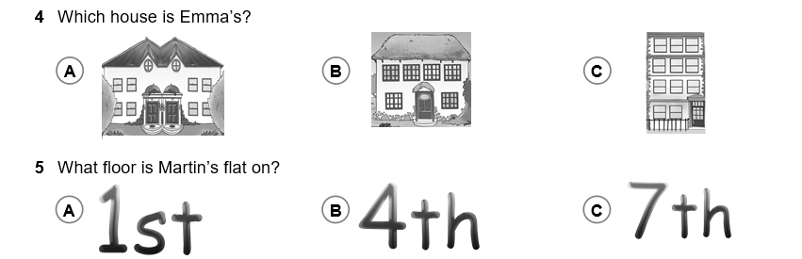

B. Listen and decide if the sentences are R (right) or W (wrong).
1 There are two windows in my bedroom.

2 Paula’s birthday party is on Friday.

3 Ben’s favourite room is the living room.

4 There is a park next to my house.

5 Martin’s house is on Central Avenue.

C. Listen and choose the correct answer.
1 a The wardrobe is opposite / next to the window.

2 b Paula has got a gym class on Saturday / Friday.

3 d The sofa / armchair is in Ben’s parents’ bedroom.

4 e There is a small cottage / big cottage in the park near my house.

5 f Martin’s birthday party / anniversary is on Friday evening.

