Name and surname: _________________ Date: ____________
Grade: _________________ /31
- Label the pictures. Napiši točan naziv ispod sličica.

taxi plane train tram ship
bus helicopter motorcycle
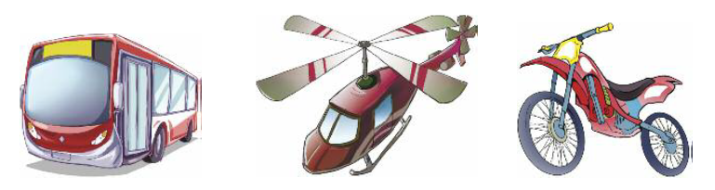


___________________ __________________ __________________


________________ _____________________ _____________________

________________ _____________________ __/8

2 Write the correct animal.
Upiši točan naziv životinje.
1 There aren’t many g _ _ _ _ _ _in the world.
2 A l _ _ _ is dangerous.
3 My grandma has lots of d _ _ _ 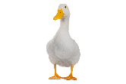
4 I am afraid of s _ _ _ _ .
5 A f _ _ 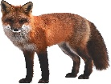is a very clever animal.
6 An e _ _ _ _ _ _ _ is the biggest land animal.
7 A p _ _ _ _ _  can talk. ___/7

3 Choose the correct answer – was / were. Zaokruži točan odgovor – was / were.
1 I was / were school yesterday.
2 My parents was / were at the bank last week.
3 Luke was / were ill.
4 They was / were on a break.
5 You was / were a good student. ___/5

4 Write the correct form of past simple.
E.g. We played football yesterday.
1 They __________________ (invite) the whole class to a party.
2 Susan ____________________ (play) the piano when she was younger.
3 My mum ___________________ (finish) the report just in time.
4 It ___________________ (rain) the whole day!
5 The plain _________________ (land) on time. ___/5

5 Write negative sentences using past time. Napiši negativne rečenice koristeći past simple.
E.g. We didn’t travel to Italy.
1 Kevin _________________ (not/wash) his bike.
2 My sister ________________ (not/clean) her room.
3 We ___________________ (not/have) anything for dessert. ___/3

6. Write past simple irregular verbs. Napiši nepravilne glagole u past simplu.
eat - ____________ have - _____________ do - __________ __/3

LISTENING COMPREHENSION ___/10

A. Listen and choose the correct answer (A, B or C).
1 Who did Ben go on holiday with?
A his friends B his family

2 Where did Ben go on holiday?
A the Philippines B Vietnam

3 What was the weather like in the mornings?
A cool B sunny

4 What did he most enjoy there?
A going to the beach B going to the zoo

5 How did he feel?
A happy B bored

B. Listen and choose the correct answer.
1 The weather was hot but it rained / snowed every day.
2 Ben stayed in a hotel near the castle / beach.
3 While on holiday, Ben went walking / shopping in the afternoons.
4 Ben was always / never bored while on holiday.
5 Ben suggests that they meet this Sunday / Saturday.

